How To: Checking Finance Reports
- Begin on the DAODAS Portal tab of GMS
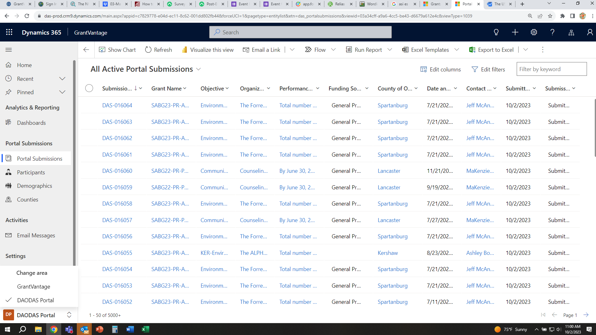
- Search your agency’s SABG23 grant.
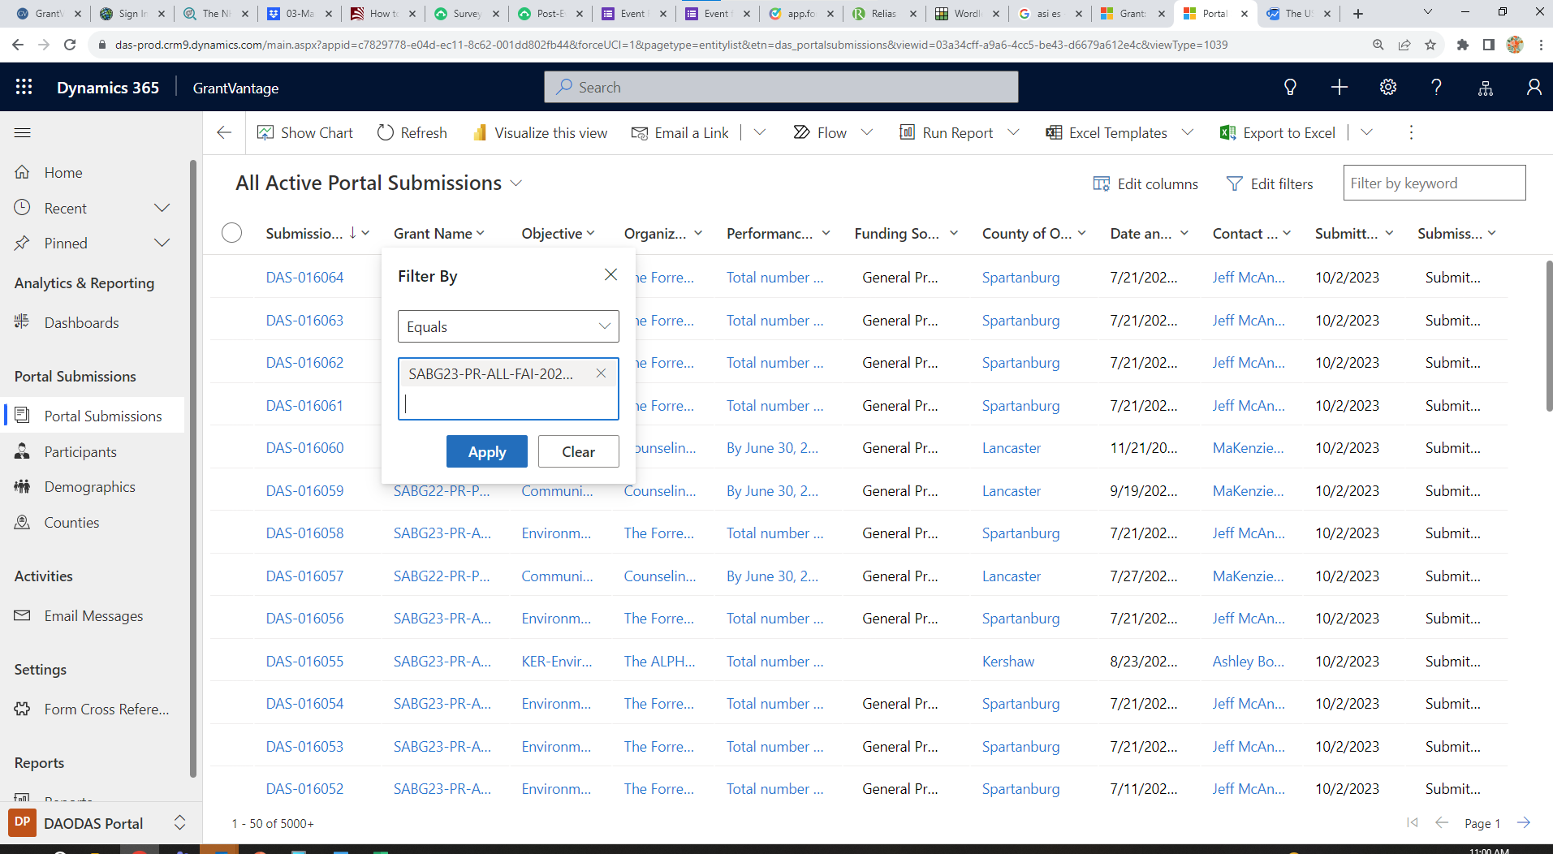
- Sort the date by newest to oldest in order to track services by month.
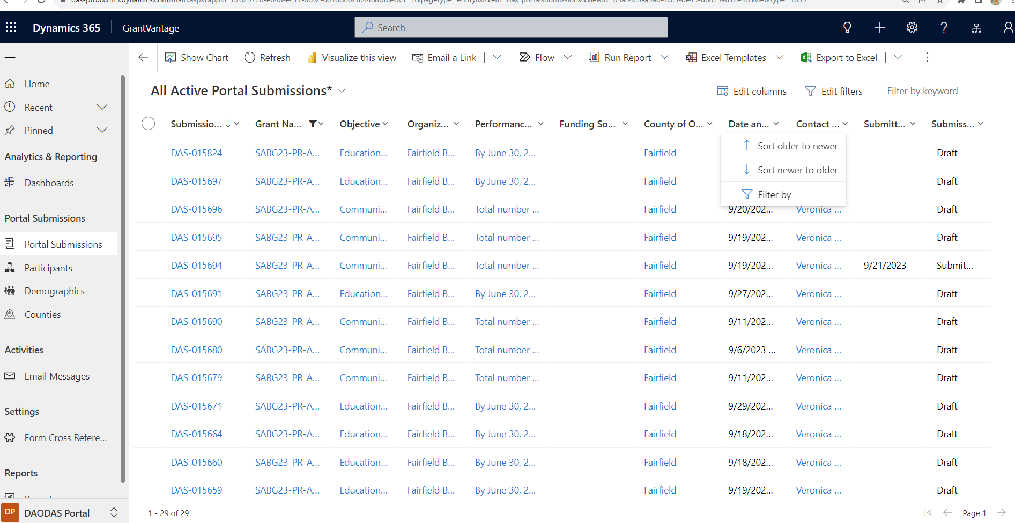
- For ease of strategy checking, add a data column for strategy. Steps below:
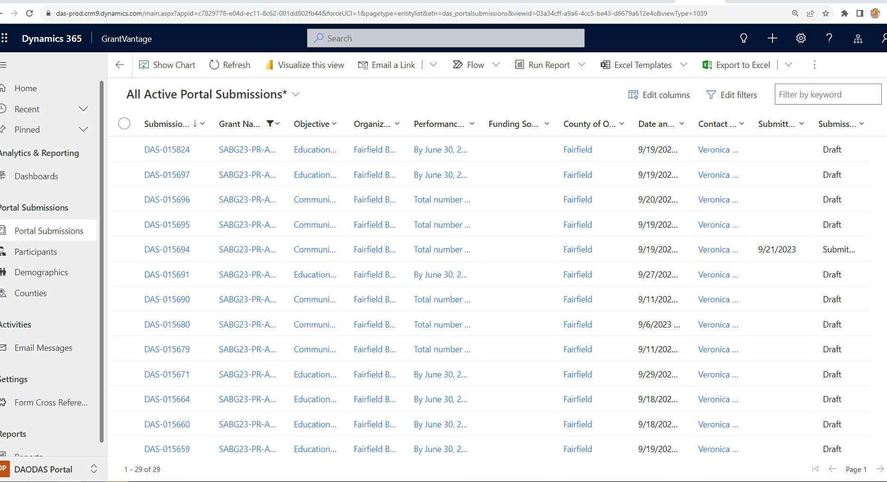
- Click “Edit Columns” then Add a column for strategy.
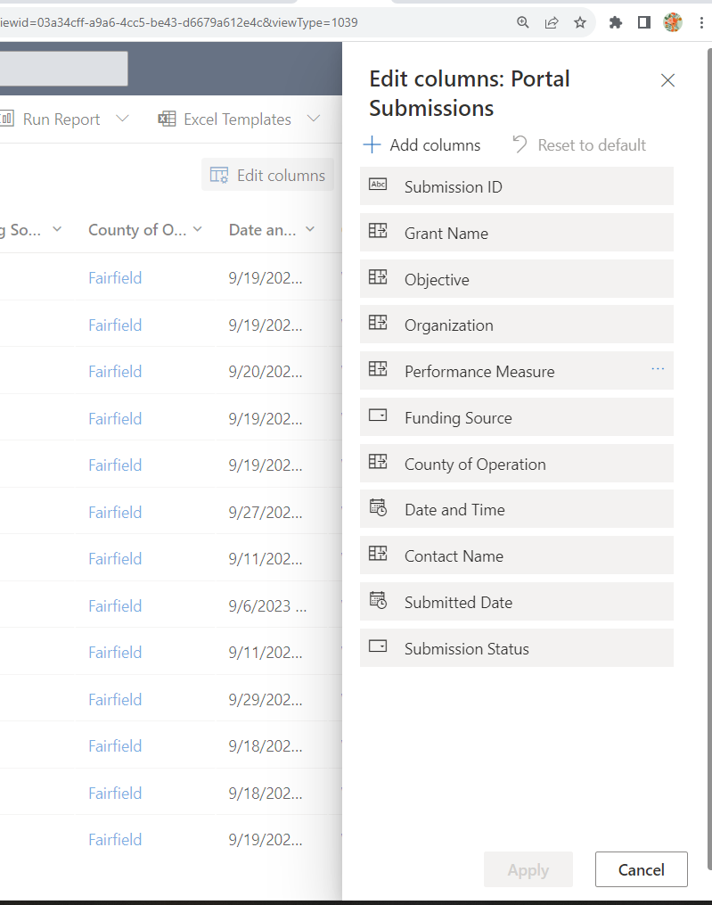
- Search “Strategy” in the box and select it, then hit “Close”
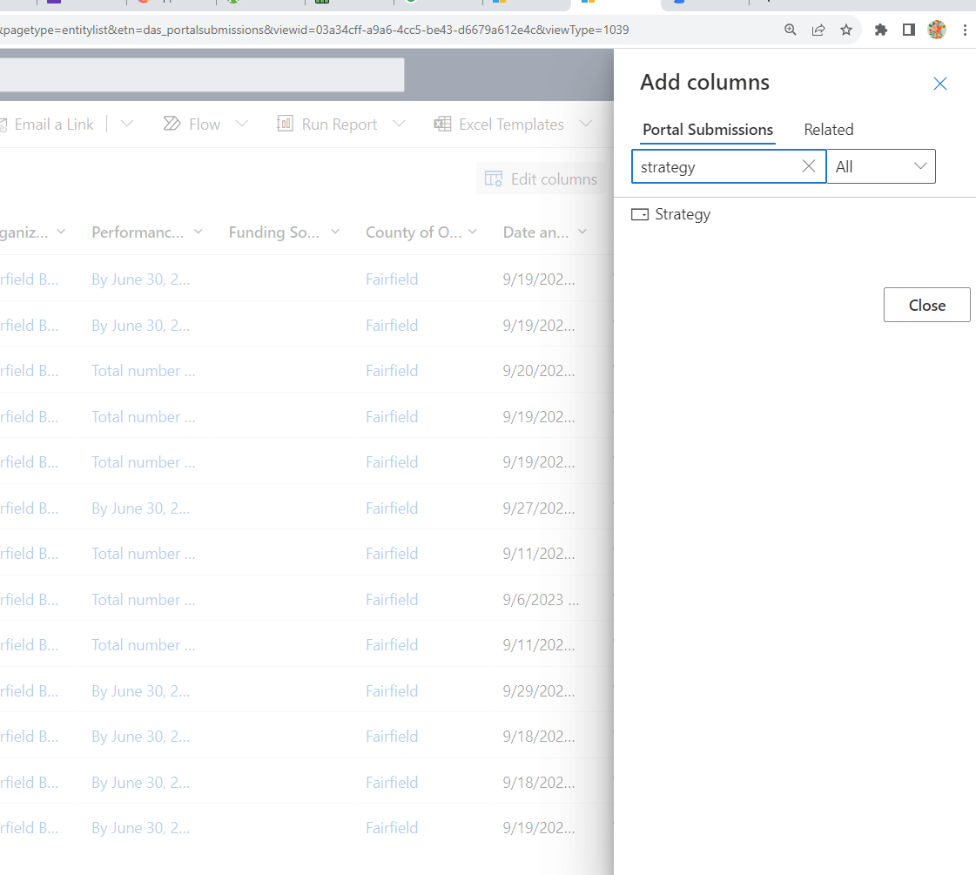

- After hitting “close,” Strategy should appear on the column list. Then hit “apply” to reflect the Strategy data column on your report.
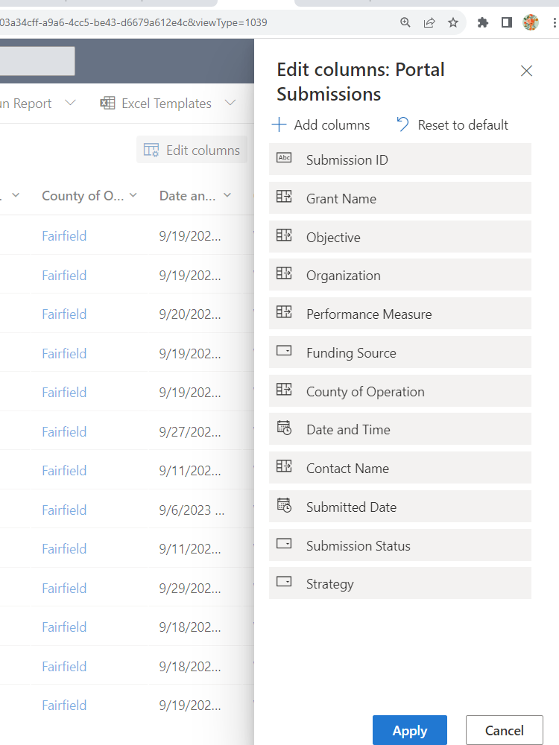

- Now you can compare your grant, date of event, and strategy of service for the drawdown and disbursements.
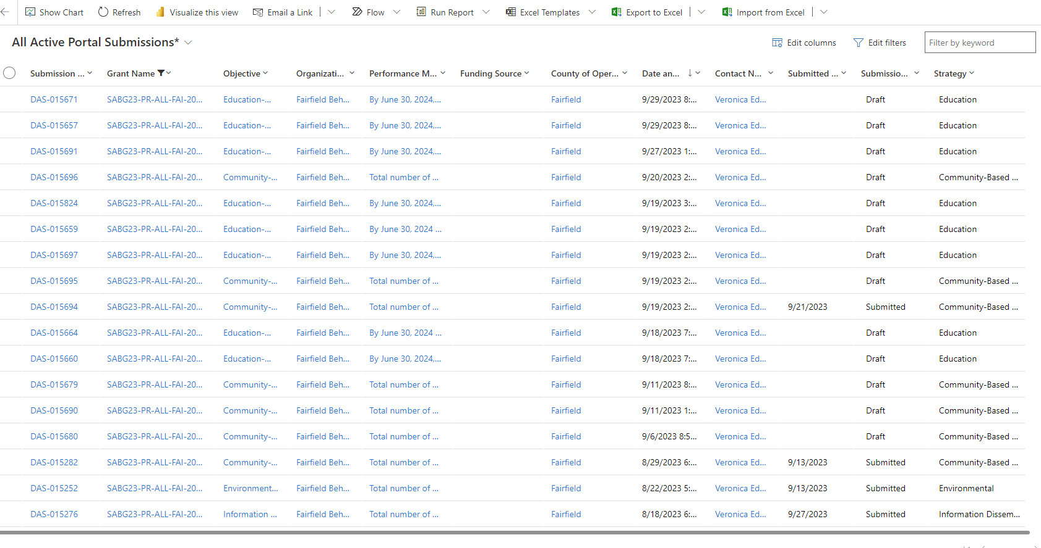

- Compare each strategy submitted for each month by the strategies listed under drawdowns and disbursements for SAB23. Please notify DAODAS Prevention if any questions arise.

